Press Release
For Immediate Release

Fast Fashion vs Green Fashion: Jockey prioritises quality over quantity
As the fast fashion industry continues to grow, concerns about the environmental and social impact of this business model have come to the forefront. According to the June 2023 Global Consumer Insights Pulse Survey released by PWC, more than 70% of respondents said that they were willing to pay more for sustainably produced goods ‘to some or to a great extent’ while eight out of ten consumers said that they would pay up to 5% more for sustainably produced goods. While some retailers prioritise speed and affordability over sustainability, Jockey is taking a different approach. The iconic international brand is committed to providing consumers with top-of-the-line garments that are not only high-quality but also eco-friendly.
When it comes to the fashion industry, there are generally two distinct approaches: fast fashion and green fashion. Fast fashion is characterised by the production of low-cost, low-quality clothing that is designed to be easily disposable, while green fashion focuses on producing sustainable, high-quality garments that are made to last. Jockey South Africa, which has been synonymous with quality for over a century, has taken a strong stance in favour of green fashion. According to Jockey’s National Sales Manager Rob Hogg, prioritising the environment and consumer satisfaction is at the heart of Jockey's commitment to green fashion.
One of the key differences between fast fashion and green fashion is the materials used in production. Fast fashion relies heavily on synthetic materials like polyester and nylon, which are derived from non-renewable resources and could potentially take centuries to break down in landfills.
Jockey has made significant strides in reducing its carbon footprint by minimizing the use of synthetic materials in its products and opting for more natural fabrics such as bamboo cotton, recyclable tencel, modal and nylon based products sourced from repurposed fabrics and yarn. An example of this is their build-a-pack garments which are made of 100% cotton fabric, 100% cotton gusset and latex free elastic. The end result is a non-fraying, hypo-allergenic, lightweight and breathable product for customers to enjoy.
In addition to using eco-friendly materials, Jockey has also made changes to its in-house production process, that includes implementing measures to minimise waste during the manufacturing and packaging process. Jockey’s packaging is starting to be made from recyclable materials and is designed to be easily recyclable.
“Jockey South Africa is definitely going the green route. We have been applying ourselves over the last few years in this area and will continue to do so going forward. We want to establish ourselves as leaders in sustainable fashion so our goal is to provide the best, most comfortable, practical products in keeping with best practices in sustainability for our customers,” explains Hogg.
With its commitment to sustainability and eco-friendly products, Jockey South Africa is helping to lead the way in the fashion industry. The brand's focus on quality and sustainability has resonated with consumers who are increasingly aware of the environmental impact of fast fashion.
Jockey's message is clear, sustainable and eco-friendly fashion is not just a trend, it's a commitment to the planet and future generations. As consumers become more aware of the impact of their purchasing decisions, brands like Jockey South Africa are helping to pave the way for a more sustainable fashion conscious industry.
ENDS.
Words: 539
Images: Jockey’s sustainable products
Distributed on behalf of: Jockey South Africa
Date: July 2023

Notes to the editor:
About – 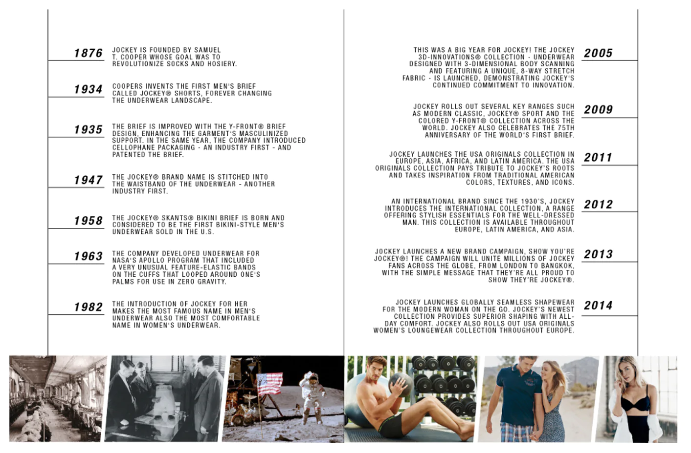

For more information or visuals, please contact Janna Strang on janna@rainmakermarketing.co.za / 082 551 3865 or email Mbali Mpofu on mbali@rainmakermarketing.co.za

